**Home Service Solution**

**Introduction:**

***In today's busy work culture, people often struggle to balance professional commitments with family life. Unexpected issues further compound the challenge, diverting attention away from important tasks. Many envision a stress-free home with no maintenance concerns, where services are easily accessible and hassle-free. In such situations, online home services emerges as a crucial tool, offering convenience and efficiency in daily life by simplifying home services.***

**Background Study:**

*Sheba(*[*www.sheba.xyz*](http://www.sheba.xyz)*):*  ***is a leading online home service in Bangladesh that connects homeowners with local service professionals. It offers a wide range of home services, including remodeling, repairs, maintenance, and more.***

*Porch (*[*www.porch.com*](http://www.porch.com/)*):****Porch is a website that helps homeowners find trusted professionals for home improvement projects. It provides access to a network of licensed contractors, architects, and designers, making it easier to find the right professionals for your project.***

**Requirement Analysis:**

1. **User Category:**

There are 4-types of Users here. They are:

* Admin
* Supplier
* Service provider
* Customer

1. **Features**

In this project the “Service Provider” has the following features:

* Requesting for boosting account
* Real-time availability calendar for service providers
* Ability for service providers to set their own pricing up to a range
* Re-Scheduling and request for cancellation if order booked
* Payment gateway

In this project the “Customer” has the following features:

* Service request submission
* Appointment scheduling
* Place order, order cancels and review
* Rating and review

To develop this project, we have used the following:

* Figma

**This is the customer dashboard where the customers can see the prices of available services, request for any service, previously taken services and place orders.**

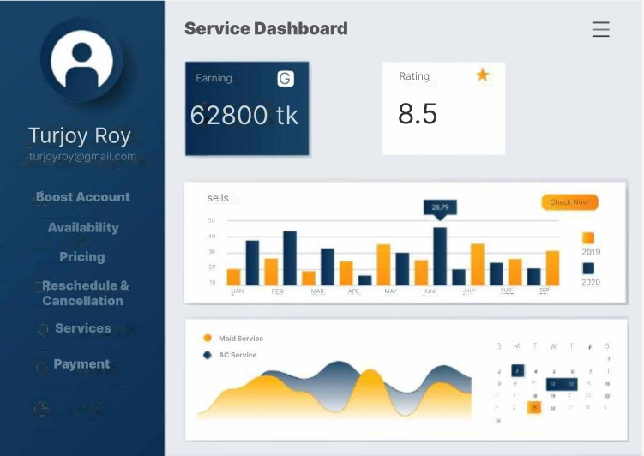

**This is the service provider dashboard.**